DYI API

<https://www.udemy.com/course/the-complete-web-development-bootcamp/learn/lecture/39461822#announcements>

Rapid API shows APIs developed by others. A few free

<https://rapidapi.com/hub>

API -

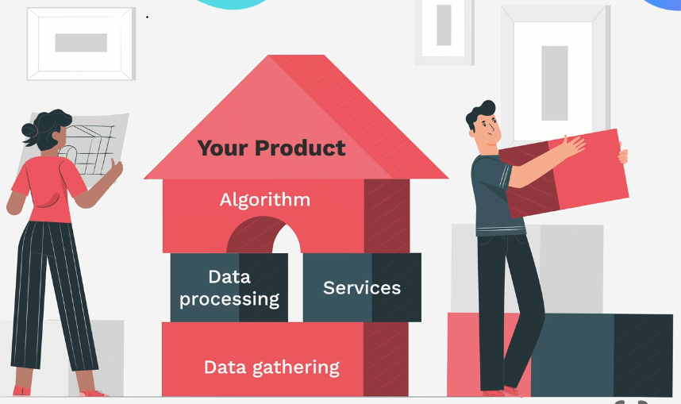

What makes an API Monetizable ?

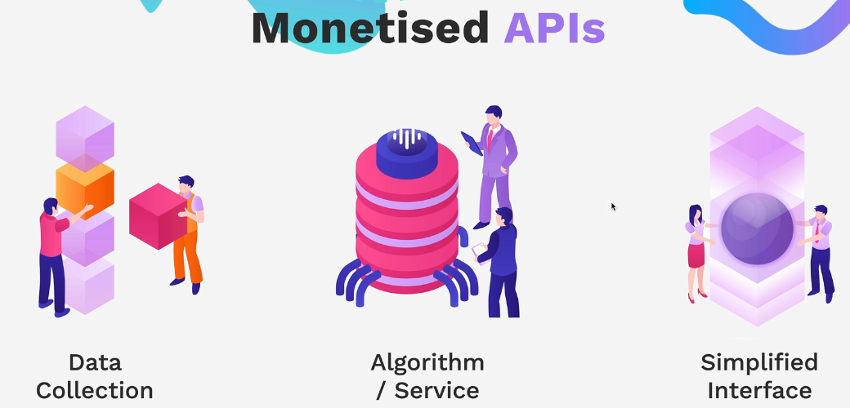

Large collection of data useful to others

Algorithm like distance between 2 points by car, complex version would be Chat Gpt

Simplified Interface – like ordering a pizza , google maps is an API – Dominos Pizza API

APIs can be internal – inventory tracking, backends are like an internal, private API

REST API , Representational state transfer API – architecture

**HTTP methods**

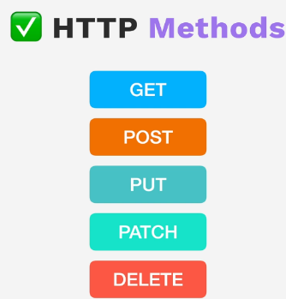

**Standard output** like JSON or xml -representational part

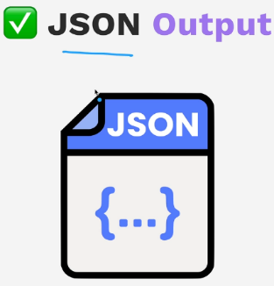

Client and Server separate are on different systems or files and can message each other back and forth to get requests and make responsive. Can evolve and be separate / scalable from one another

**Stateless** – each request from client to server contains all the information that is needed to understand and process the request. Server doesn’t store client side state or client data between requests.

Each single request can be completed and each single response is also complete without need to know what happened previously.

Allows server to serve many clients

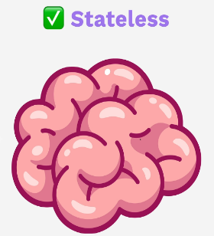

**Resource Based** – uses unique resource identifier known as a Resource Locator, such and a URL

The WWW is considered one of the most successful implementations of RESTful architecture.

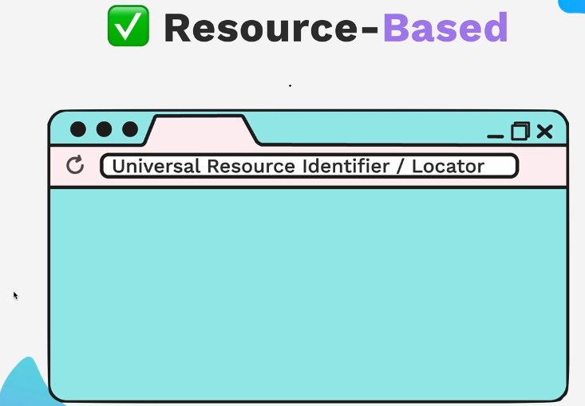

HTTP GET Method – look at the process of importing a json file with postman to do this exercise.

Postman JokeAPI - when creating a postman collection docs can be created right from postman and saved. You can view it locally or in the case to this documentation for the course publish it to the web.

<https://documenter.getpostman.com/view/6048123/2s9XxsTv8Y>

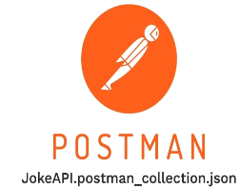

Endpoints to build

Restart here – this section was not well put together or helpful

<https://www.udemy.com/course/the-complete-web-development-bootcamp/learn/lecture/39461828#announcements>